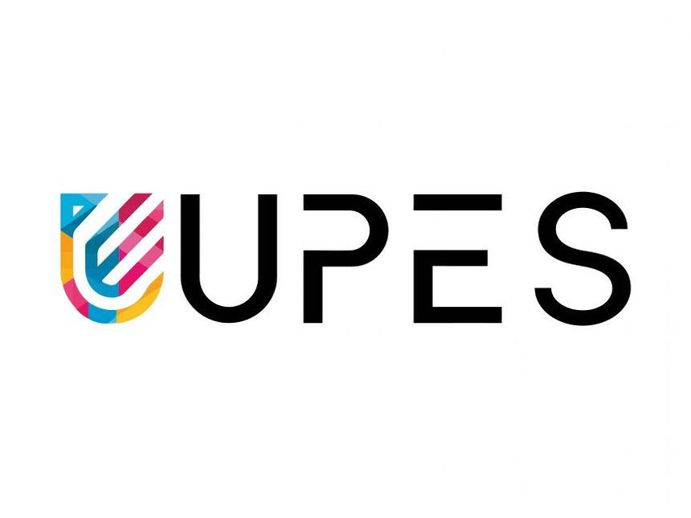
PYTHON PROGRAMMING LAB FILE

Name: Krishna Som
Sap ID: 590025475
Batch: 34
Teacher: Sugandha Sharma

Experiment 10:

Objective 1: Create numpy array to find sum of all elements in an array.
Code:
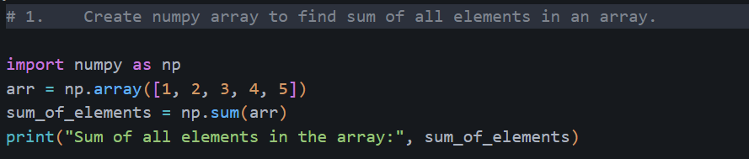
Output:
Objective 2: Create numpy array of (3,3) dimension. Now find sum of all rows & columns individually. Also find 2nd maximum element in the array.
Code:
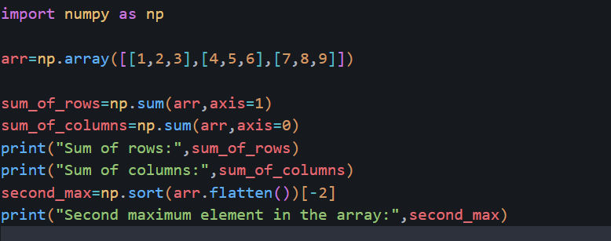
Output:
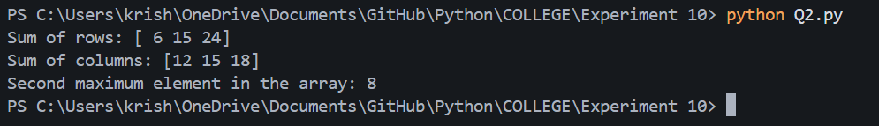

Objective 3: Perform Matrix multiplication of any 2 n*n matrices
Code:
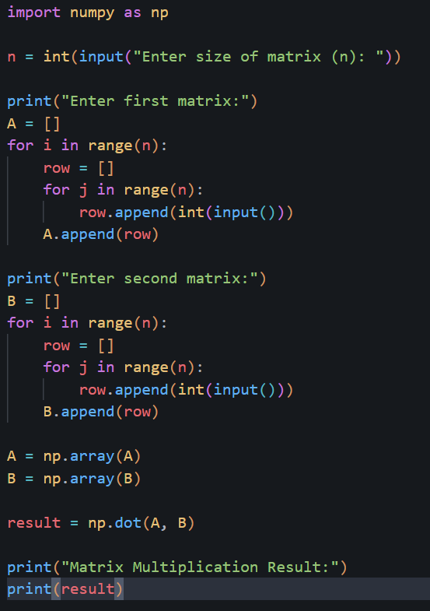
Output:
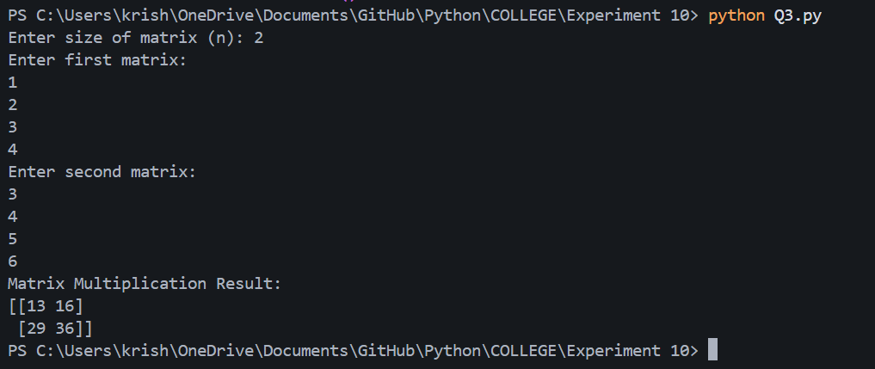

Objective 4: Write a Pandas program to get the powers of an array values element-wise.
Note: First array elements raised to powers from second array

Code:
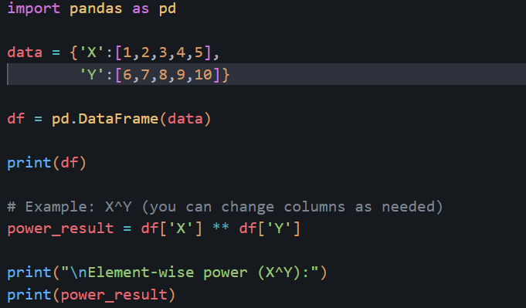
Output:
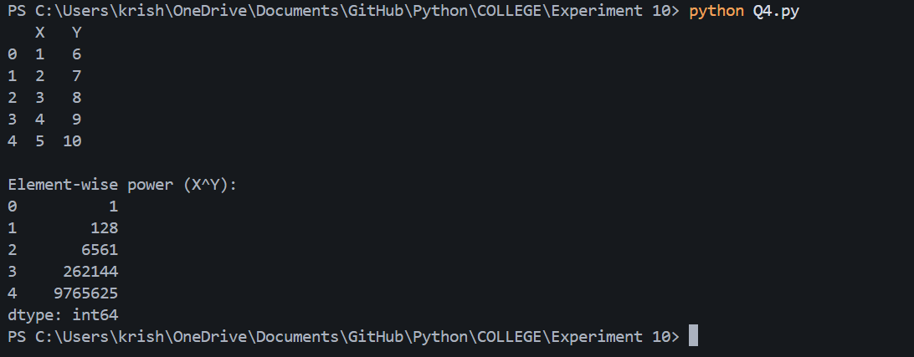

Objective 5: Write a Pandas program to get the first 3 rows of a given DataFrame.
Code:
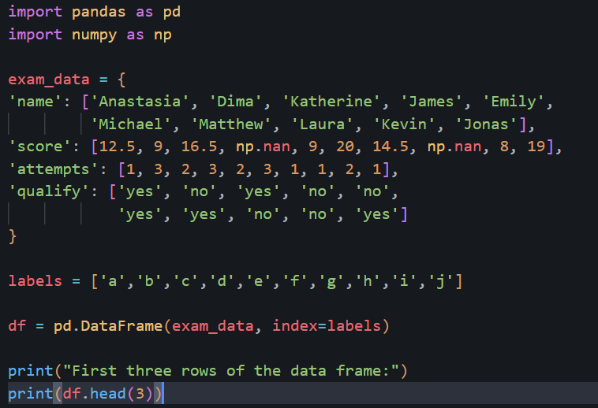
Output:
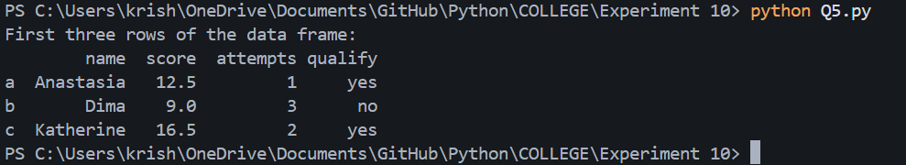

Objective 6: Write a Pandas program to find and replace the missing values in a given DataFrame which do not have any valuable information.
Code:
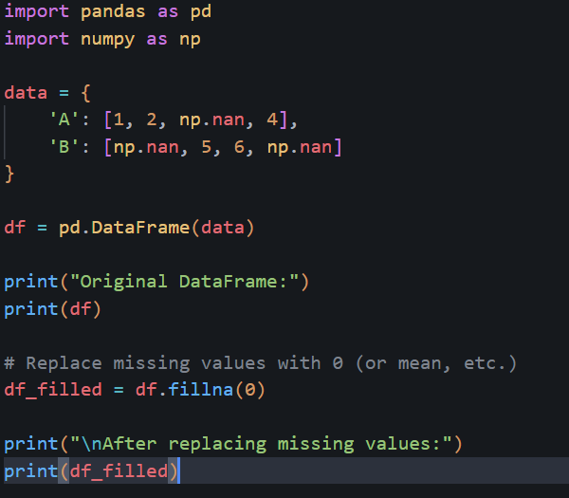
Output:
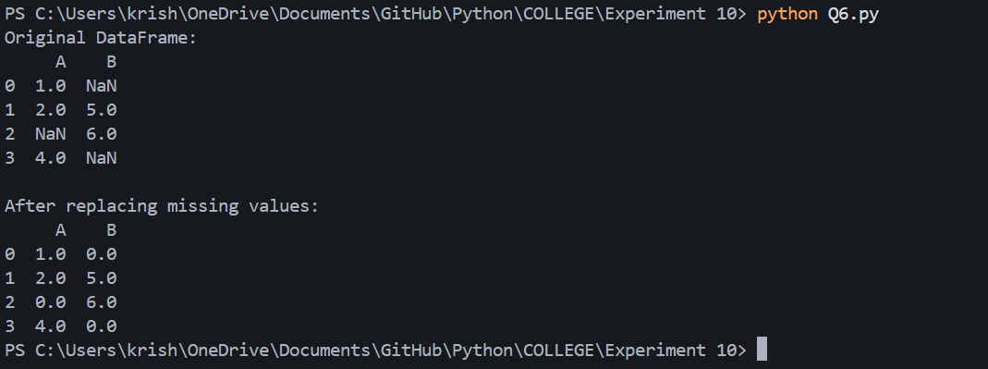

Objective 7: Create a program to demonstrate different visual forms using Matplotlib
Code:
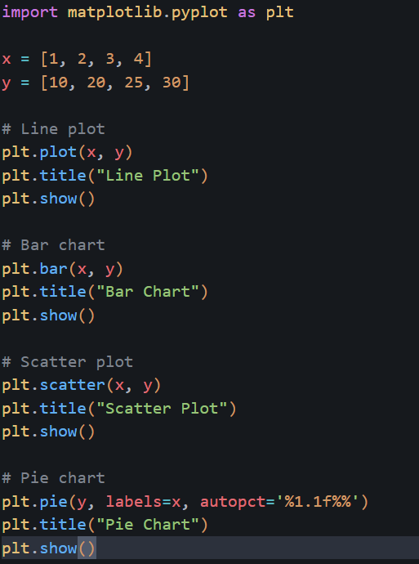
Output:
